**FUNCTIONAL AND TECHNICAL COMBINED DOCUMENTATION**

**Page (18): Trade Register for Equity (Front End Url:** http://localhost:8100/page18/Page18)

**Functional Picture:**

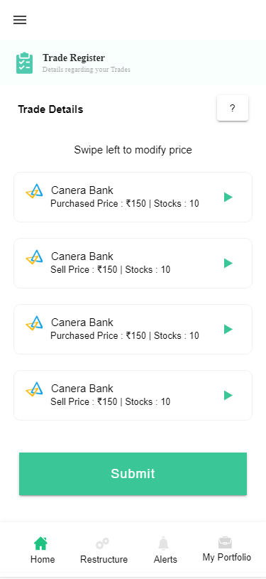

**In this Page, the user is going to see the list of stocks that are currently in his portfolio. The user can slide each section and can edit his actual transaction price from Page 17(Add or Update Stocks)**

**Technical Explanation (Front End and Back End):**

**In Page18.tsx, we are calling following 1 API:**

1. TradeRegisterAPI: see backend python file. In this we are doing GET requests.

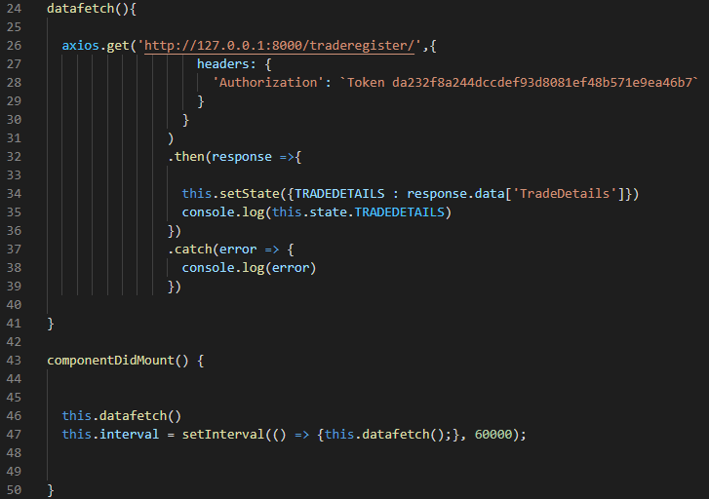

**As you can see, we are calling the** TradeRegisterAPI

**using this url:** [**http://127.0.0.1:8000/traderegister/**](http://127.0.0.1:8000/traderegister/)**. In this we are taking the stocks data to populate those on the front end.**

**Kindly see the given below backend Code for this GET request.**

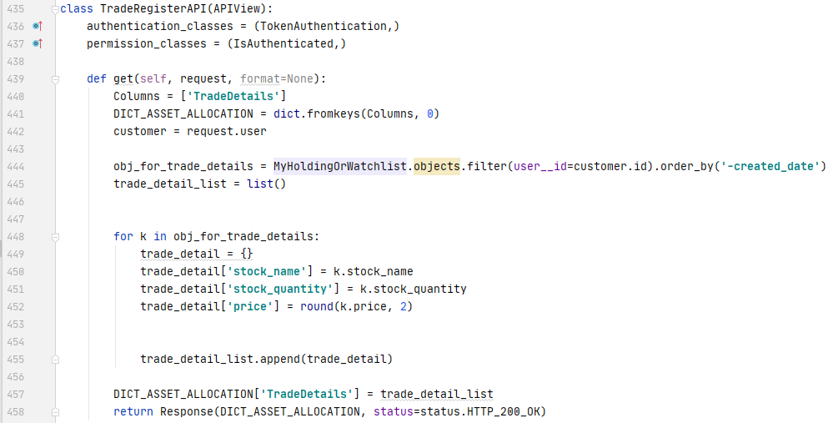

**The Above API is taking the data from the MyHoldingOrWatchlist Database throwing the data on the front end through Response.**

**Kindly see the database given below:**

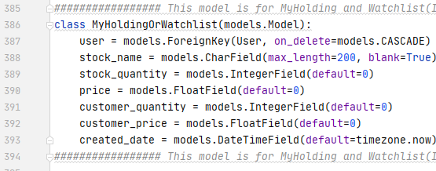

**DONE!!!**